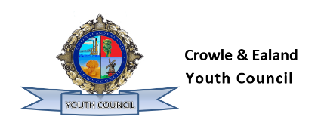

Minutes of the Youth Council Meeting of Crowle and Ealand Town Council (C&ETC) held at The Chapels, Crowle Cemetery, Crowle, DN17 4LN, at 5:30 pm, on Tues 10th June 2025.

Youth Councillors (YC) Present: Youth Mayor L Botfield, Deputy Youth Mayor H Kirk, YC L Mills.
Council Committee Members Present: Cllr Holgate, Cllr Reed, Cllr Simm
Officers Included: Kirsty Dunn, Town Clerk (TC)

Members of the Press/Public: Nil
Public Forum: Nil

YC/009 Apologies for Absence:
Nil

YC/010 Declarations of Interest:
Nil

YC/011 Minutes of the previous meeting:
Minutes of the annual and monthly meetings held on 13th May 2025 are received as a true record.

YC/012 Youth Mayors Report/Town Mayors Report
Attended Methodist Church event, delivering a speech about the Youth Council and drew the tombola.
Wrote an article about the Youth Council for the Regen News about YC projects and events.
Discussion about the skatepark – Axhomle Academy Google form asking people what they want to do. This is being chased tomorrow. Plans to go into primary schools to do a skatepark/youth council assembly.
On Sat they will be attending St Norberts Church Summer Fayre. Promotional activities are hoped.

YC/013 Action Plan
Christmas event – cinema Sat 6th Dec 25 from 3.30 pm for younger viewers and 4.30 pm.Second Star to the Left and Christmas Chronicles.

Ealand Duck Pond. Lydia Coles, Severn Trent is the liaison to assist with local community projects. The aim is to get this team to help organise a public consultation and planning application design.
Youth Council are to consider the area and potential plans and return them to the next meeting.

The 106 park development is on the full council meeting for resolution.

YC/014 Co-Option
Thomas Holgate was co-opted onto the Youth Council by a unanimous vote.

Future Agenda Items

Election and how it will be managed.

Meeting closed at 18:00 hours

Signature: DRAFT pending signature
Date: 8th July 2025
Designation: YC Mayor L Botfield

